

**COMSATS University Islamabad (Lahore Campus)**

**<Lab Assignment 2> – SPRING 2024**

|  |  |  |  |  |  |
| --- | --- | --- | --- | --- | --- |
| Course Title: | Game Development | Course Code: | CSC495 | Credit Hours: | 3 |
| Course Instructor/s: | Saira Aslam | Program | BSE | | |
| **Submission Deadline** | **11:55 pm, 26-3-2024** | **Maximum Marks:** | **50** | | |
| **Important Instructions / Guidelines:**   * Submit a 10 seconds video, 4 screenshots, and all your scripts in Lab Assignment 1 submission at google classroom * Paste your screenshots and scripts inside Lab Assignment-1 submission file provided | | | | | |

***Question No 1.***

***CLO: <3>; Bloom Taxonomy Level: <****Apply****>* [80]**

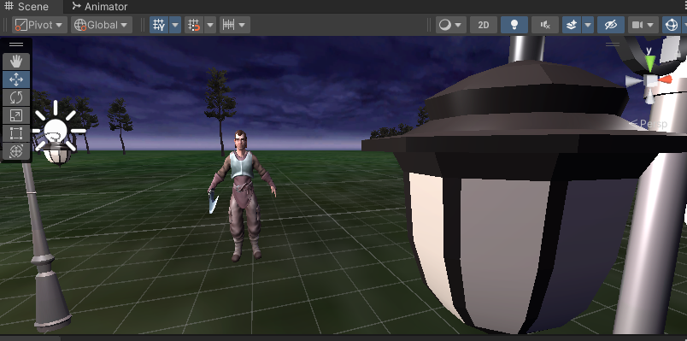

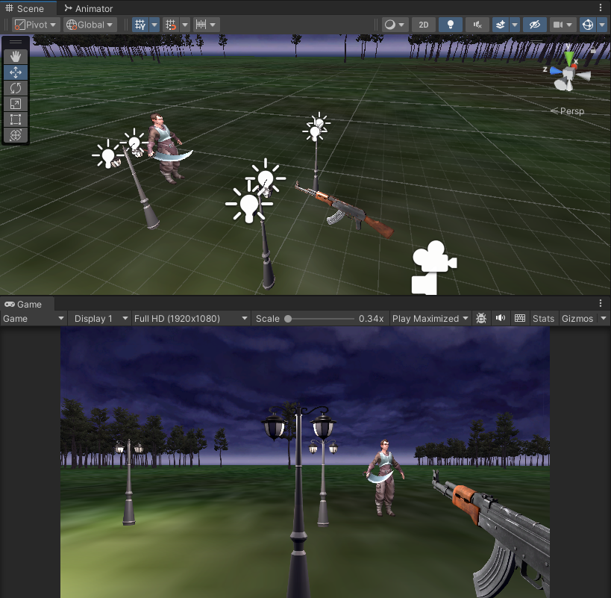

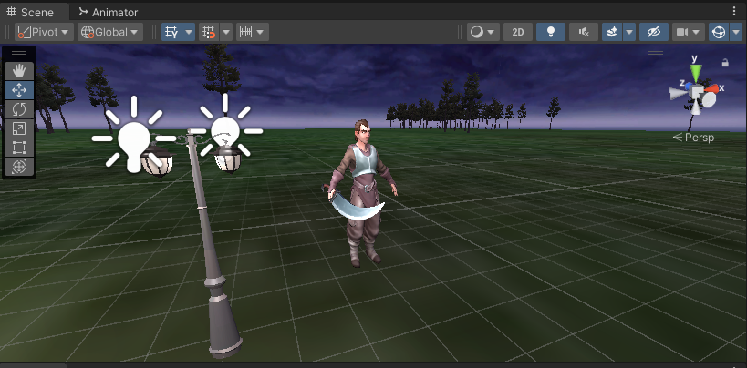

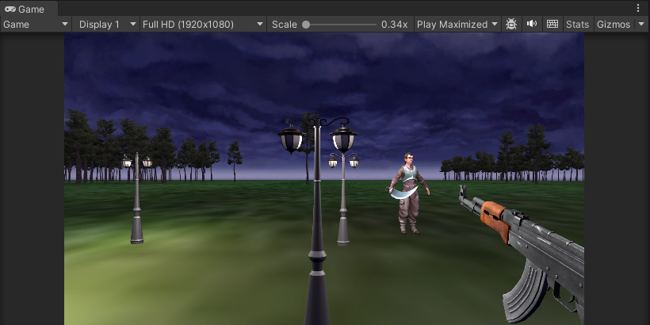

**bulletScript.cs**

using System.Collections;

using System.Collections.Generic;

using UnityEngine;

public class bulletScript : MonoBehaviour

{

    Rigidbody r;

    // Start is called before the first frame update

    void Start()

    {

        r = GetComponent<Rigidbody>();

    }

    // Update is called once per frame

    void Update()

    {

        r.AddForce(transform.forward * 100);

    }

}

**bulletControllerScript.cs**

using System.Collections;

using System.Collections.Generic;

using UnityEngine;

public class bulletControllerScript : MonoBehaviour

{

    public GameObject bullet;

    // Update is called once per frame

    void Update()

    {

        if(Input.GetMouseButtonDown(0))

        {

            Instantiate(bullet,transform.position,transform.rotation);

        }

    }

}

**enemyScript.cs**

using System.Collections;

using System.Collections.Generic;

using UnityEngine;

public class enemyScript : MonoBehaviour

{

    public GameObject fps;

    Animator anim;

    // Start is called before the first frame update

    void Start()

    {

        anim = GetComponent<Animator>();

    }

    // Update is called once per frame

    void Update()

    {

        transform.LookAt(fps.transform);

    }

    public void OnCollisionEnter(Collision col)

    {

        if(col.gameObject.name.StartsWith("bullet"))

        {

            anim.SetBool("isDead",true);

        }

        Destroy(col.gameObject);

    }

}